|  |  |  |
| --- | --- | --- |
| **GUÍA DE ESTUDIO N°1** | | |
| **Nombre:** | **Curso: 6** | **Fecha:** |
| **Unidad: My World**  **Objetivo**:  **0A7** Leer comprensivamente textos literarios adaptados y auténticos simples identificando: Tema general del texto, personajes, lugares y tiempo.  **0A5** Leer y demostrar comprensión de textos adaptados y auténticos simples, no literarios: Solicitar y entregar información personal. | | Puntaje Total:  **39** |
| **Instrucciones:**   * Esta guía de estudio está realizada con el fin de reforzar tus conocimientos previos. Es de carácter formativo y una vez retornes a clases se evaluará, recuerda realizarla a conciencia y con responsabilidad. * El tipo de actividades que a continuación desarrollaras han sido anteriormente trabajadas en clases, por lo que serán de total entendimiento para ti.   Una vez descargada e impresa la guía recuerda que:   * Debes responder con lápiz pasta azul o negro. * Cada ítem cuenta con su respectiva instrucción y puntaje. | | Puntaje Obtenido  Calificación |

**Using the following text answer the questions (utilizando el siguiente texto responda las preguntas)**

**The city where I live**

My name is Clark, and I will tell you about my city.

I live in an apartment. In my city, there is a post office where people mail letters. On Monday, I go to work. I work at the post office. Everyone shops for food at the grocery store. They also eat at the restaurant. The restaurant serves pizza and ice cream.

My friends and I go to the park. We like to play soccer at the park. On Fridays, we go to the cinema to see a movie. Children don't go to school on the weekend. Each day, people go to the hospital when they are sick. The doctors and nurses take care of them. The police keep everyone safe. I am happy to live in my city.

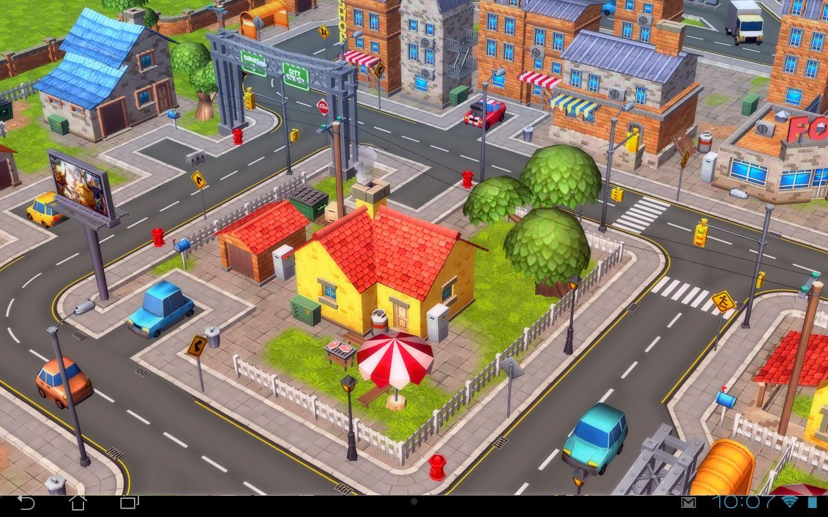

1. **With your dictionary translate these words related to the text** (con tu diccionario traduce estas palabras relacionadas con el texto)**. 1 point each**

|  |  |  |  |  |
| --- | --- | --- | --- | --- |
| **TELL:** | **LETTER:** | **GO:** | **EVERYONE:** | **FOOD:** |
| **ALSO:** | **SERVE:** | **SEE:** | **WEEKEND:** | **SICK:** |

1. **Create a crossword using 7 words of the vocabulary** (Cree un crucigrama usando 7 palabras del vocabulario) **1 point each**

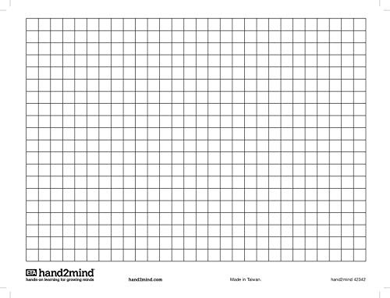

1. **Select the correct alternative** (seleccione la alternative correcta) **2 points each**

|  |  |
| --- | --- |
| 1. **Where does Clark work?** a) in an apartment   b) in a grocery store  c) in the cinema  d) in the post office | 1. **Where do people buy food?** a) in the grocery store   b) in the hospital  c) in the park  d) in the cinema |
| 1. **When does Clark go the cinema?** 2. Monday 3. Friday 4. Each day 5. The weekend | 1. **Who keeps everyone safe?** 2. The nurses 3. The children 4. The police 5. The doctors |
| 1. **How does Clark feel about his city?** 2. Sad 3. Happy 4. Sick 5. Angry |  |

1. **Now it is your turn, complete the chart with your personal information** (complete la tabla con su información personal**) 2 points each**

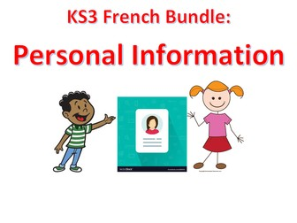

|  |  |
| --- | --- |
| **NAME** |  |
| **SURNAME** |  |
| **AGE** |  |
| **CITY WHERE YOU LIVE** |  |
| **SPORT YOU LIKE** |  |
| **BIRTHDAY** |  |

**GOOD LUCK!**