|  |  |  |
| --- | --- | --- |
| **GUÍA DE ESTUDIO N°1** | | |
| **Nombre:** | **Curso: 7** | **Fecha:** |
| **Unidad:**  **The Natural World**  **Objetivo**:  **OA13** Demostrar conocimiento y uso del vocabulario aprendido: Expresiones de uso común asociadas a las funciones del nivel.  **OA5** Leer y demostrar comprensión de textos adaptados y auténticos simples, no literarios relacionados con los temas y las siguientes funciones del año: Solicitar información | | Puntaje Total:  **56** |
| **Instrucciones:**   * Esta guía de estudio está realizada con el fin de reforzar tus conocimientos previos. Es de carácter formativo y una vez retornes a clases se evaluará, recuerda realizarla a conciencia y con responsabilidad. * El tipo de actividades que a continuación desarrollaras han sido anteriormente trabajadas en clases, por lo que serán de total entendimiento para ti.   Una vez descargada e impresa la guía recuerda que:   * Debes responder con lápiz pasta azul o negro. * Cada ítem cuenta con su respectiva instrucción y puntaje. | | Puntaje Obtenido  Calificación |

**Using the following texts answer the questions** (usando el siguiente texto responda las preguntas)

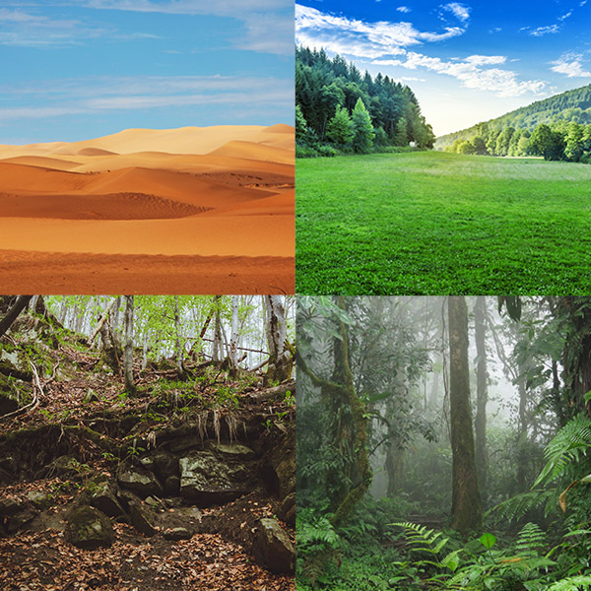A habitat is the type of environment in which plants and animals live. A habitat is dictated by the climate and the geography. Deserts, rainforests and mountains are all examples of habitats where you can find particular types of plants and animals. In the mountains the temperatures are normally low. At very high altitudes there is also less oxygen, making life difficult for both animals and plants. Deserts have a dry climate with few plants. There are extremely hot days and very cold nights. It may appear that deserts do not have many animals or plants, but a closer inspection can reveal high biodiversity. Rainforests are wet and warm. It always rains a lot and they have an incredible diversity of life. There you can see a lot of types of animals and plants, too. In the mountains the temperatures are normally low. At very high altitudes there is also less oxygen, making life difficult for both animals and plants.

**I. - TRUE OR FALSE (justify the false), 2 point each.** (verdadero o falso, escribe ‘T’ para verdadero y ‘F’ para falso, las afirmaciones falsas debe justificarlas).

**1 The text is about the universe.**

**2 A habitat is a type of planet.**

**3 In rainforest you can see a lot of animals and plants.**

**4 Deserts have a dry climate.**

**5 In mountains the temperatures are cold.**

**6 Rainforest are wet and dry.**

**7 A habitat is dictated by the climate and the geography.**

**8 in Rainforests always rains a lot and they have an incredible diversity of life.**

**9 In mountains at very high altitudes there is also less oxygen.**

**10 Deserts, mountains and rainforest are type of colors.**

**II. – Vocabulary, 1 point each.** (traduzca las siguientes palabras relacionadas con el texto).

|  |  |
| --- | --- |
| **HIGH** |  |
| **LOW** |  |
| **A LOT** |  |
| **SEE** |  |
| **BOTH** |  |

|  |  |
| --- | --- |
| **LIVE** |  |
| **ALL** |  |
| **TYPE** |  |
| **APPEAR** |  |
| **ALL** |  |

**III. – Using the words of the vocabulary complete the sentences, 2 point each.** (usando las palabras del vocabulario complete las siguientes oraciones).

|  |  |  |  |  |
| --- | --- | --- | --- | --- |
| **TYPE** | **HAVE** | **FIND** | **CLIMATE** | **HIGH** |
| **EXTREMELY** | **SEE** | **BOTH** | **LOW** | **WHERE** |

1. In the mountains the temperatures are normally __________.
2. Deserts have a dry ___________ with few plants.
3. At very ________ altitudes there is also less oxygen.
4. Rainforests and mountains are all examples of habitats ________ you can find particular types of plants.
5. Making life difficult for ________ animals and plants.
6. You can _______ particular types of plants and animals.
7. Deserts do not _________ many animals or plants.
8. There you can _______ a lot of types of animals and plants, too.

**IV.- Choose and translate 5 sentences of the last item** (escoge y traduce 5 oraciones del item anterior). **2 points each.**

1. _______________________________________________________________________
2. _______________________________________________________________________
3. _______________________________________________________________________
4. _______________________________________________________________________
5. _______________________________________________________________________

**GOOD LUCK!**