GUÍA DE ESTUDIO N°1
Nombre: | Curso: 8 | Fecha:
Unidad: The Natural World  Objetivo:  OA9 Demostrar comprensión de ideas generales e información explícita en textos adaptados y auténticos simples, en formato impreso o digital, acerca de temas variados.  OA15 Escribir para informar, expresar opiniones y narrar, usando: Palabras, oraciones y estructuras aprendidas. Conectores aprendidos. |  | Puntaje Total:  57
Instrucciones:  - Esta guía de estudio está realizada con el fin de reforzar tus conocimientos previos. Es de carácter formativo y una vez retornes a clases se evaluará, recuerda realizarla a conciencia y con responsabilidad.  - El tipo de actividades que a continuación desarrollaras han sido anteriormente trabajadas en clases, por lo que serán de total entendimiento para ti.  Una vez descargada e impresa la guía recuerda que:  - Debes responder con lápiz pasta azul o negro.  - Cada ítem cuenta con su respectiva instrucción y puntaje. |  | Puntaje Obtenido  Calificación

I.- Read the following text and choose the correct alternative (lea el siguiente texto y seleccione la alternative correcta). 2 POINTS EACH

Penguins
Penguins are among the most popular of all birds. They only live in and around the South Pole and the continent of Antarctica. No wild penguins live at the North Pole. There are many different kinds of penguins. The largest penguin is called the Emperor Penguin, and the smallest kind of penguin is the Little Blue Penguin. There are 17 different kinds of penguins in all, and none of them can fly.
Penguins have to be able to survive in the some of the Earth's coldest and windiest conditions. They are great swimmers and have thick layers of fat to protect them from the bitter cold. Even in their freezing cold habitats, penguins still have to watch out for predators such as killer whales and seals.

1.- Where do Penguins live?
a) the South Pole b) the North and South poles c) the North Pole

2.- Penguins are....
a) great at flying. b) great at swimming. c) all very large.

3.- Which is not a PREDATOR of penguins?
a) killer whale b) seal c) hawk

4.- Which is the largest penguin?
a) King b) Commander c) Emperor

5.- How many different kinds of penguins are there?
a) eighteen b) seventeen c) seventy

II.- Resolve the vocabulary (resuelva el vocabulario) 1 POINT EACH

EARTH: | SURVIVE: | KIND: | WILD: | TYPE:
PET: | RESIST: | THICK: | NONE: | WILD

III.- Find the synonym or similar term to each word (encuentre el sinonimo o un termino similar para cada palabra) 2 POINTS EACH.

BIRDS – OCEAN – TYPES – COUNTRY – RESIST – PLANET – INDOMITABLE - PETS

EARTH
SURVIVE
KINDS
PENGUINS
WILD

IV.- Read each cloud and complete the table (lea cada nube y complete la tabla) 1 POINT EACH.

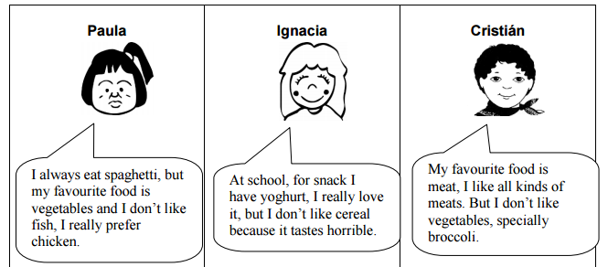

 | Paula | Ignacia | Cristian
likes
doesn´t like

V.- Read and underline five verbs in past tense (Lea el texto y subraye 5 verbos en pasado) 1 POINT EACH.
NOTA: Recuerda que tenemos una muy buena pista para identificar los verbos regulares en pasado, terminan en –ed. Para descubrir los restantes tendrás que leer el texto.

Javiera was a good student. She liked sports very much and specially she loved playing tennis and in the year 2006, she went to Miami to take part in a championship of tennis. She arrived to the city, early in the morning, at 7 o’clock and her trainer came to the airport.

VI.- Complete the survey with your personal information (complete la encuesta con tu informacion personal) 1 POINTS EACH.

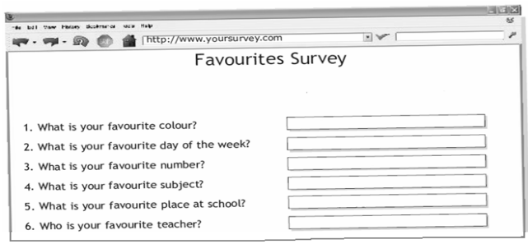

VII.- Write the words in the correct category (escribe las palabras en la categoria correcta) 1 POINT EACH.

BLACK - PLAY - MONDAY - NOSE - TEN - APPLE - SISTER - LION – DAUGHTER – RUN

1.- ANIMAL :
2.- FRUIT :
3.- NUMBER :
4.- COLOUR :
5.- FAMILY MEMBER :
6.- VERB :
7.- PART OF THE BODY:
8.- DAY OF THE WEEK :

GOOD LUCK!

