**ENGLISH WORKSHEET**

**Guía de Nivelación**

|  |
| --- |
| **NAME:** _____________________________________-____________________**GRADE:**12th**DATE:** ______________  **TOTAL SCORE:**30 POINTS,20 %**SCORE:** ____ L. **ACHIEVEMENT:** 60 % **GRADE:** |
| **OBJETIVO DE APRENDIZAJE (LEARNING OBJECTIVE):**desarrollar comprensión lectora a través de ejercicios basados en tiempo presente. |
| **HABILIDAD (SKILL):** Aplicar |
| **INSTRUCCIONES (INSTRUCTIONS):**   * **READ EACH QUESTION CAREFULLY BEFORE ANSWER**. Lea atentamente cada pregunta antes de responder. * **LOOK CAREFULLY TO THE CHARTS, THEY ARE USEFUL!.**Mire cuidadosamente las tablas, son de mucha ayuda! * **THIS ACTIVITY VALUES 33 POINTS, it means 20 %.**ESTA ACTIVIDAD VALE 33 PUNTOS, es decir 20% * **THIS ACTIVITY MUST BE SENT SOLVED ON TUESDAY 23RD, 2020.**Esta actividad debe ser enviada resuelta el día miércoles **24 de marzo** del 2020 a mi correo:[**dsalgueiro@liceomixto.cl**](mailto:dsalgueiro@liceomixto.cl)**,** indicando en el asunto nombre, apellido y curso. |

**I.- Take a look at this chart in present simple tense and remember how using verb be and action verbs. (De un vistazo a la siguiente tabla en tiempo presente, recuerde cómo usar el verbo to be y verbos de acción) 3 POINTS E/C**

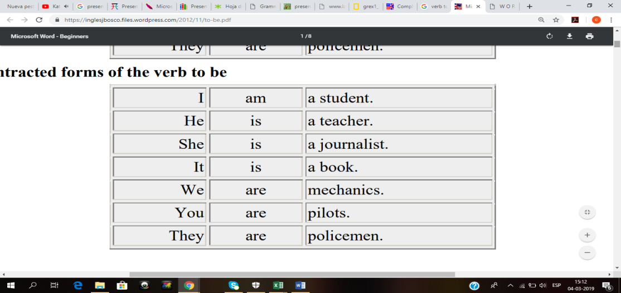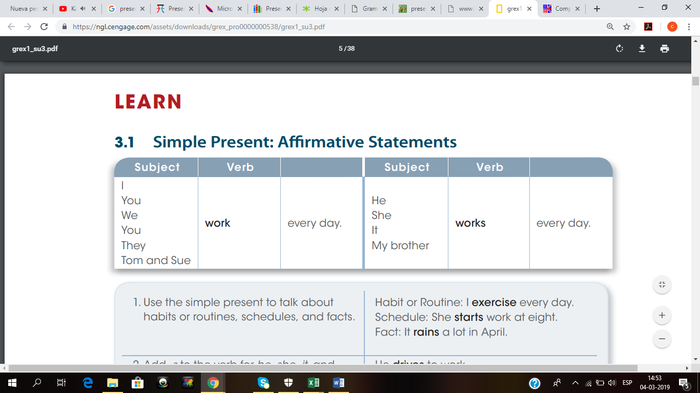

1. **Read carefully and answer the following questions about it. (Lea cuidadosamente y responde a las siguientes preguntas basadas en ella.)**

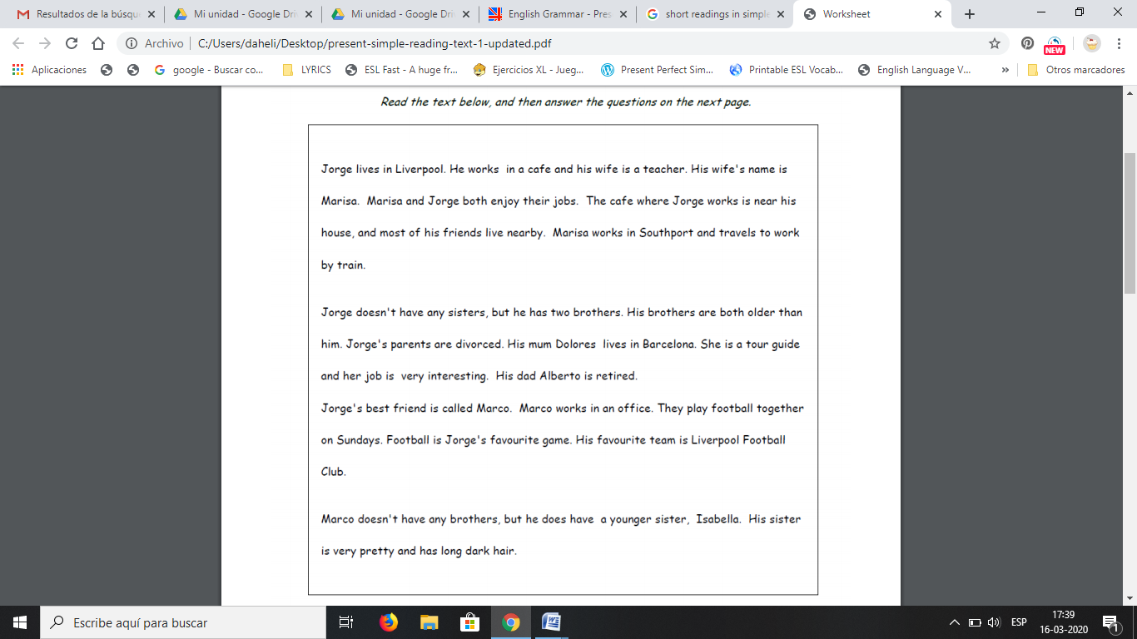

|  |  |
| --- | --- |
| 1. Is Jorge married? | **Example:** yes, he is. Melissa is his wife. |
| 1. Are Jorge and Melissa teachers? |  |
| 1. Where does Melissa work? |  |
| 1. Does Melissa come to work by car? |  |
| 1. Is Jorge the youngest in his family? |  |
| 1. What is his mother´s occupation? |  |
| 1. What s his best friend´s name? |  |
| 1. What´s his father´s occupation? |  |
| 1. How many sisters does he have? |  |
| 1. Is Isabella ugly? |  |

1. **Read loudly every question and every answer to make better your pronunciation! (Lea en voz alta cada pregunta y cada respuesta para mejorar tu pronunciación)**