**ENGLISH WORKSHEET**

**Job Ad**

|  |
| --- |
| **NAME:** _______________________________________________ **GRADE:** 11th **DATE:** ______________  **TOTAL SCORE:** 25 points, **20% of the final grade** **STUDENT SCORE:** ____ L. **ACHIEVEMENT:** 60 % **GRADE:** |
| **OBJETIVO DE APRENDIZAJE (LEARNING OBJECTIVE):** Repasar contenidos previos. Aplicar vocabulario relacionado a la unidad my first job. |
| **HABILIDAD (SKILL):** Aplicar |
| **INSTRUCCIONES (INSTRUCTIONS):**   * **READ EACH QUESTION CAREFULLY BEFORE ANSWER**. Lea atentamente cada pregunta antes de responder. * ***YOU CAN USE AN ONLINE DICTIONARY wordreference:*** *Puedes usar el diccionario* [*www.wordreference.com*](http://www.wordreference.com)*)* * ***THIS WORKSHEET MUST BE SENT SOLVED BY E-MAIL TO*** [***dfaundez@liceomixto.cl***](mailto:dfaundez@liceomixto.cl) ***ON TUESDAY 23RD, 2020:*** *Resuelve y envía esta guía por correo el martes 23 de marzo del 2020. No olvidar indicar en el asunto: nombre, apellido y curso.* * **DON´T FORGET TO USE THE FOLLOWING VOCABULARY:**No olvide utilizar el siguiente vocabulario: loyal- organized- friendly- talented- humble- empathetic- creative- hardworking- excellent communication skills- great computer skills – tidy- chatty – passionate- socially responsible- commited |

**I.- Complete the following chart using the examples.** Complete el siguiente cuadro utilizando los ejemplos.**(15 points)**

|  |  |  |  |  |
| --- | --- | --- | --- | --- |
| **JOB** | **DUTIES** | **SKILLS** | **OPINION** | **TRANSLATION/JOB** |
| **A Doctor** | Works in a clinic or hospital and looks after sick people | Responsible reliable, caring | Stressfull |  |
| **A teacher** |  |  |  | Enfermera |
| **A lawyer** | Works with people who needs legal help |  | Boring |  |
| **An engineer** | Designs and constructs tools, machines |  | Difficult |  |
| **A writer** |  |  |  |  |
| **A firefighter** |  | Strong, physically fit, brave |  |  |

**II.- Read this job ad and answer the following questions.** Lea el siguiente anuncio y responda las siguientes preguntas. **(5 points)**

|  |
| --- |
| **WOWEE MAGAZINE** |
| **Writers wanted!** |
| **Wowee magazine** is looking for writers for its website. Pay is based on the number of people who read your articles. You may also receive free tickets to events and free products to test. This is a great opportunity to get valuable work experience |
| **We want people who are:**   * **Chatty** * **Creative** * **Organized** * **Punctual** |
| **Contact us at info@woweemagazine** |

|  |
| --- |
| **1.- What is the name of the company?** |
|  |

|  |
| --- |
| **2.- What job is needed?** |
|  |

|  |
| --- |
| **3.- What is the pay for this job?** |
|  |

|  |
| --- |
| **4.- What are the requirements for this job?** |
|  |

|  |
| --- |
| **5.- How can you apply for this job?** |
|  |

**III.- Read the paragraph below and fill in the answers.** Lea los párrafos y responda las preguntas. **(5 points)**

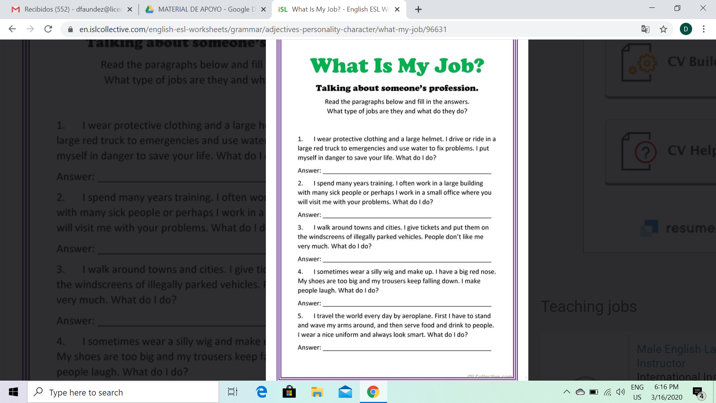

You are a Fire fighter